**Benefits of CSS**

CSS stands for, Cascading Style Sheet and is a major factor in the production of websites all over the world. CSS is responsible for styling the website. CSS has a list of major benefits, such as, better performance. The use of CSS can improve the performance of a website by improving how it responds to search engines. CSS can make your website one of the best websites in the world, by just incorporating some good CSS structure techniques.

CSS can have a major role on how you site appears in Google. When CSS is used to style your header tags, you are making very easy to find your site, and as far as Google this is a great thing and they tend to reward sites with great structure, by placing their sites at the top of search listings and all it takes is to have a great head tag using CSS.

One other useful benefit that CSS has it the ability to allow your content to come alive, with things such as rollover and image transparency, and this is all possible with the use of CSS. CSS is also a very lightweight styling language that does not bloat your web page and it allows Google to navigate your page more efficiently. This is all because of CSS.

CSS can be placed in a number of places in your site. It can be placed inline, which means that it can be placed directly in the code itself. CSS can also be embedded into the HTML document itself in the head portion of the document. CSS can also be linked to the HTML document by using link rel syntax, and what this does is that it allows you to source in your CSS style sheet from a separate document. Below I have placed a diagram of how CSS is structured.

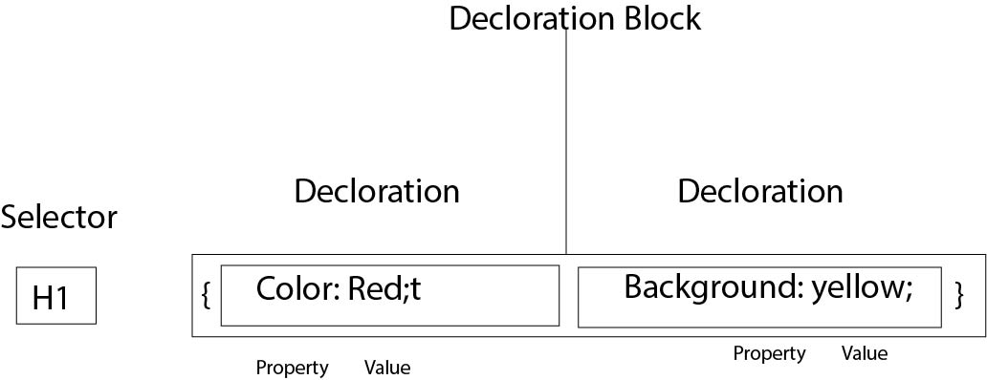

**Work Cited**

**Amanda Annan. "3 Benefits of Using CSS." http://www.designersplayground.com/pr/3-benefits-of-using-css/. October 29, 2011. LeXolution IT Services . June 5, 2013. <http://www.designersplayground.com/pr/3-benefits-of-using-css/>.**